Cross-quantilogram: USDJPY and USDCHF
Method 20 / daily log returns / expanding quantiles / Alpari D1 full available history

Study setup
Logical pair: USDJPY , USDCHF
Broker symbols: USDJPY_i , USDCHF_i
Snapshot: 2026-11-03_majors_alpari_D1
Timeframe: D1
Matched return window: 1999-01-05 to 2026-11-02 (UTC bar dates)
Matched return count n: 7185
Dropped unfinished last bar dated 2026-11-03 UTC after a tick-volume check against the prior complete day.
Quantiles: expanding window, min history 252 days
tau in [0.05, 0.2]; k=0..10; headline tau=0.05, k=1
Complete matched rows (Excel): USDJPY-USDCHF_CQ_D1.xlsx
Complete matched rows (HTML table): USDJPY-USDCHF_CQ_D1_data.html

Method carried forward
The cross-quantilogram rho_tau(k) measures linkage among centered quantile-hit indicators of matched daily log returns of close, ln(close_t / close_t-1). Quotes are not inverted. At each date t, the tau-quantile uses only returns through t (expanding window) after a minimum history of 252 days. Hits are h_t = 1(r_t < q_t) - tau. rho_tau(k) is the normalized cross-product of h_x,t with h_y,t+k. Levels tau in {0.05, 0.20} and lags k=0..10 are pre-specified; headline is tau=0.05, k=1 both directions. Same-sample Pearson r is a side check. This is not causation and not a trading signal.

Results (headline)
rho_USDJPY->USDCHF(tau=0.05,k=1): 0.011798
rho_USDCHF->USDJPY(tau=0.05,k=1): 0.039488
rho_USDJPY->USDCHF(tau=0.20,k=1): 0.022387
rho_USDCHF->USDJPY(tau=0.20,k=1): 0.029553
Pearson r: 0.399461

CQ table (tau=0.05)
k | rho_USDJPY_to_USDCHF | n_USDJPY_to_USDCHF | rho_USDCHF_to_USDJPY | n_USDCHF_to_USDJPY
0 | 0.23332818 | 6934 | 0.23332818 | 6934
1 | 0.01179805 | 6933 | 0.03948837 | 6933
2 | 0.03156728 | 6932 | 0.02365568 | 6932
3 | 0.01177851 | 6931 | 0.03551354 | 6931
4 | 0.04341576 | 6930 | -0.01196653 | 6930
5 | 0.03576379 | 6929 | 0.05527406 | 6929
6 | 0.0476459 | 6928 | 0.00779324 | 6928
7 | 0.01592507 | 6927 | 0.01965141 | 6927
8 | 0.01195135 | 6926 | 0.01172965 | 6926
9 | 0.04365359 | 6925 | 0.03150025 | 6925
10 | 0.03175198 | 6924 | 0.0117101 | 6924

Conclusion
Headline tau=0.05, k=1 for USDJPY and USDCHF: rho_USDJPY->USDCHF = 0.0118; rho_USDCHF->USDJPY = 0.0395. At tau=0.20, k=1: 0.0224 and 0.0296. Same-day tau=0.05 rho(k=0) = 0.2333. Pearson r = 0.3995. This is quantile-hit linkage, not a trading signal.

Charts
Daily closes

Daily log returns

Cross-quantilogram tau=0.05
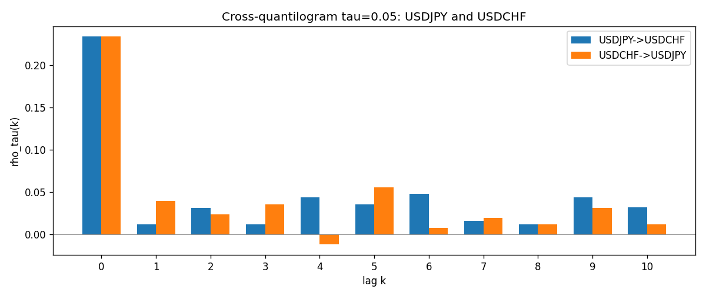

Data report
Matched rows and the CQ sheet are in the sibling Excel workbook named USDJPY-USDCHF_CQ_D1.xlsx. Embedding all rows as a Word table is impractical; this file holds column summaries and the first and last 15 matched rows.
Columns: time, USDJPY_open, USDCHF_open, USDJPY_high, USDCHF_high, USDJPY_low, USDCHF_low, USDJPY_close, USDCHF_close, USDJPY_tick_volume, USDCHF_tick_volume, USDJPY_spread, USDCHF_spread, USDJPY_real_volume, USDCHF_real_volume, USDJPY_log_return, USDCHF_log_return, USDJPY_h_t005, USDCHF_h_t005
Column summaries (matched calculation rows)
column | count | mean | std | min | 25% | 50% | 75% | max
USDJPY_open | 7185 | 113.80726 | 19.2236 | 75.693 | 104.38 | 110.984 | 120.69 | 163.824
USDCHF_open | 7185 | 1.0974395 | 0.25223318 | 0.72022 | 0.92053 | 0.98988 | 1.2375 | 1.8219
USDJPY_high | 7185 | 114.30433 | 19.285132 | 76.001 | 104.865 | 111.442 | 121.257 | 163.978
USDCHF_high | 7185 | 1.1027315 | 0.25397793 | 0.73305 | 0.92474 | 0.99353 | 1.2422 | 1.8313
USDJPY_low | 7185 | 113.28455 | 19.151449 | 75.402 | 103.87 | 110.53 | 120.17 | 163.628
USDCHF_low | 7185 | 1.0923205 | 0.25064913 | 0.08565 | 0.91719 | 0.98622 | 1.2315 | 1.8121
USDJPY_close | 7185 | 113.82023 | 19.238853 | 75.811 | 104.38 | 111.025 | 120.68 | 163.851
USDCHF_close | 7185 | 1.0974333 | 0.25214008 | 0.72025 | 0.92079 | 0.98995 | 1.2376 | 1.8217
USDJPY_tick_volume | 7185 | 106345.59 | 179437.4 | 149 | 9958 | 53202 | 92889 | 1803508
USDCHF_tick_volume | 7185 | 74334.331 | 113494.7 | 18 | 12809 | 40241 | 70443 | 858589
USDJPY_spread | 7185 | 20.263883 | 17.612444 | 0 | 6 | 11 | 30 | 50
USDCHF_spread | 7185 | 26.03215 | 24.694045 | 0 | 5 | 16 | 50 | 100
USDJPY_real_volume | 7185 | 3.4781051e+10 | 1.6093614e+11 | 0 | 0 | 0 | 0 | 3.8834203e+12
USDCHF_real_volume | 7185 | 2.3294091e+10 | 8.9133595e+10 | 0 | 0 | 0 | 0 | 1.9331921e+12
USDJPY_log_return | 7185 | 4.82e-05 | 0.00620617 | -0.03908203 | -0.00320044 | 0.00011473 | 0.00340924 | 0.05184024
USDCHF_log_return | 7185 | -6.962e-05 | 0.0065941 | -0.19545699 | -0.0033516 | 8.06e-05 | 0.00332472 | 0.09051364
USDJPY_h_t005 | 6934 | -0.0073118 | 0.20216779 | -0.05 | -0.05 | -0.05 | -0.05 | 0.95
USDCHF_h_t005 | 6934 | -0.0166859 | 0.17946844 | -0.05 | -0.05 | -0.05 | -0.05 | 0.95
First 15 matched rows (selected columns)
time | USDJPY_log_return | USDCHF_log_return | USDJPY_h_t005 | USDCHF_h_t005
1999-01-05 | -0.00017868311 | 0.0039424743 | nan | nan
1999-01-06 | 0.0075660159 | 0.013605652 | nan | nan
1999-01-07 | -0.012851583 | -0.0093883841 | nan | nan
1999-01-08 | -0.0047719894 | 0.011040268 | nan | nan
1999-01-11 | -0.016195423 | 0.0052963193 | nan | nan
1999-01-12 | 0.032310364 | -0.0098275602 | nan | nan
1999-01-13 | 0.0081373171 | -0.018259701 | nan | nan
1999-01-14 | 0 | -0.0024256692 | nan | nan
1999-01-15 | 0.0055343401 | 0.01794228 | nan | nan
1999-01-18 | 8.7600193e-05 | -0.0031856384 | nan | nan
1999-01-19 | -0.0056219403 | -7.2518946e-05 | nan | nan
1999-01-20 | -0.0053879917 | 0.0072259871 | nan | nan
1999-01-21 | 0.0084664056 | -0.0038232689 | nan | nan
1999-01-22 | 0.0060412564 | -0.0001445609 | nan | nan
1999-01-25 | -0.0073594164 | 0.0024546976 | nan | nan
Last 15 matched rows (selected columns)
time | USDJPY_log_return | USDCHF_log_return | USDJPY_h_t005 | USDCHF_h_t005
2026-10-13 | -0.0018932826 | -0.0024955621 | -0.05 | -0.05
2026-10-14 | 7.5800166e-05 | 0.0029388325 | -0.05 | -0.05
2026-10-15 | -0.0018524319 | -0.0097855323 | -0.05 | -0.05
2026-10-16 | -0.00037976126 | -0.0036230826 | -0.05 | -0.05
2026-10-19 | 0.0034946841 | 0.0036351779 | -0.05 | -0.05
2026-10-20 | -0.0022546642 | -0.0026281224 | -0.05 | -0.05
2026-10-21 | -0.00032883504 | -0.00040027413 | -0.05 | -0.05
2026-10-22 | -0.0085942669 | -0.0048036381 | -0.05 | -0.05
2026-10-23 | 0.00035080446 | 0.005652514 | -0.05 | -0.05
2026-10-26 | 0.0041238746 | 0.0018407959 | -0.05 | -0.05
2026-10-27 | 0.0027651658 | 0.0026100526 | -0.05 | -0.05
2026-10-28 | -0.00095679538 | -0.0010142111 | -0.05 | -0.05
2026-10-29 | -0.00038043789 | -0.0048680164 | -0.05 | -0.05
2026-10-30 | -0.0010596481 | 0.00071594559 | -0.05 | -0.05
2026-11-02 | 0.0026438521 | -0.0071459744 | -0.05 | -0.05

